Q1.
- If statement
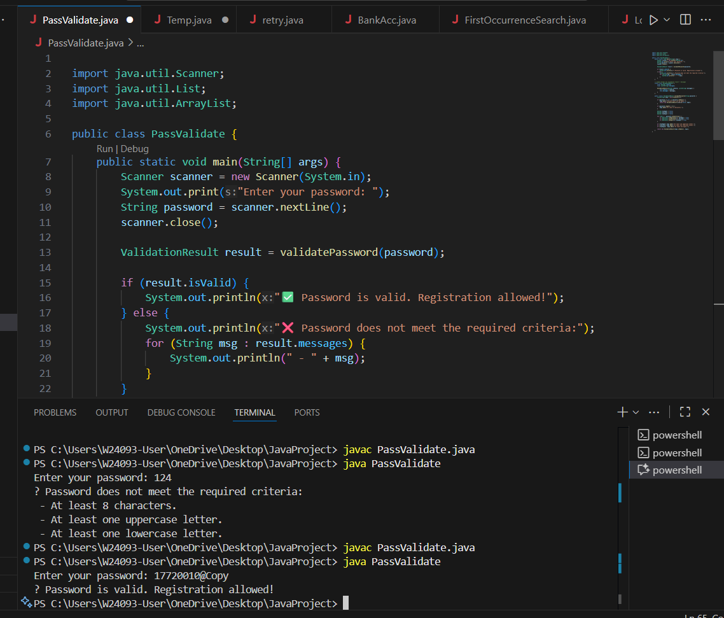

A: if statement is suitable because you can combine multiple conditions using logical operators (&&, ||).

B: switch statement is mainly for checking against specific fixed values (like int, char), so it’s not suitable for password rule validation.

C,D: while loop / do-while loop are used for repetition (running a block of code multiple times), but password validation only needs to be checked once, not repeatedly.

Therefore, using an if statement is the most appropriate choice.

Q2.
C: While Loop

In a file processing application, you usually don’t know beforehand how many lines are in the file.

A while loop is best when you want to keep repeating an operation until a certain condition is no longer true.

Example: keep reading lines while line != null.

if statement only checks once, not repeatedly.

switch statement is for handling multiple fixed cases, not continuous reading.

for loop is good when the number of iterations is known (e.g., loop 10 times), but here the number of lines is unknown.

Q3.
- switch statement
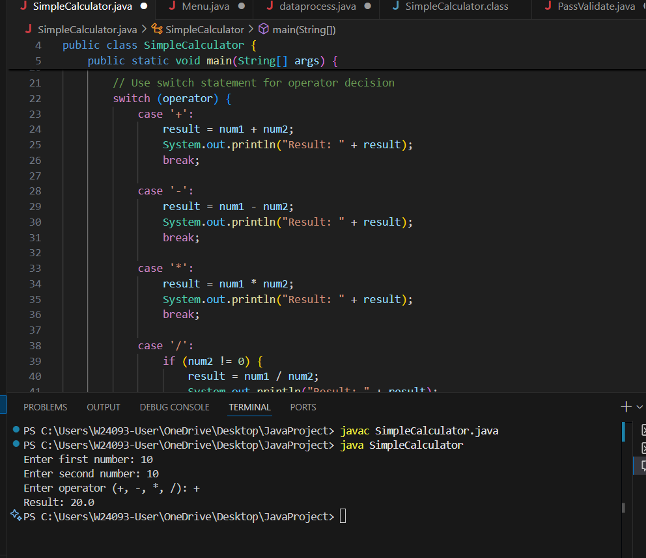

In a calculator function, the operator (+, -, *, /) has a fixed set of possible values.

A switch statement is the most efficient and clean way to branch execution based on a specific value (like the operator).

An if-else if chain could work, but it’s less readable when checking against multiple constant values.

A while loop is for repetition, not decision-making.

Nested if statements are unnecessarily complex for this case.

Therefore, a switch statement is the most efficient and readable choice for implementing a simple calculator.

Q4.
C: While loop

while (gameIsRunning) {

if (playerHealth <= 0) {
System.out.println("Game Over!");
gameIsRunning = false; // exit loop
}

// more game logic...
}

Q5.
B: Switch statement inside a do while loop
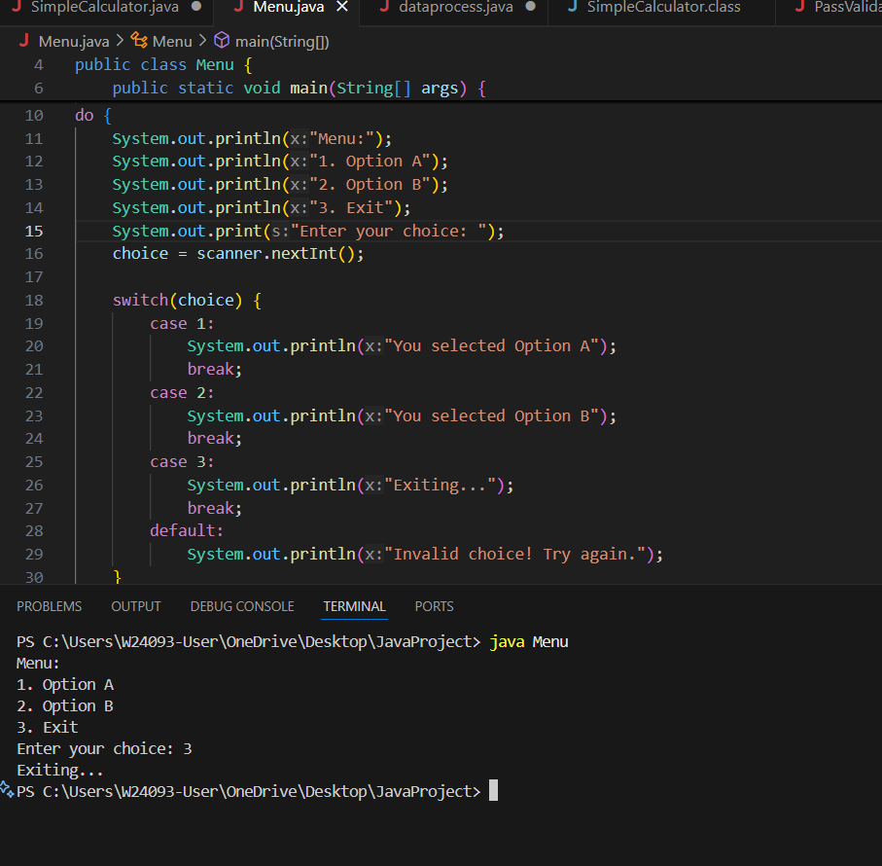
Menu keeps appearing until the user chooses 'Exit'
This requires repeating the menu continuously, which makes a loop necessary.
A do-while loop is ideal because it guarantees the menu is shown at least once before checking the exit condition.

User selects an option by number
Each menu option corresponds to a fixed value (1, 2, 3, …).
A switch statement is perfect for handling multiple fixed options efficiently and clearly.

Why not the others?
if statement: Can check a condition once, but not suitable for multiple menu options.
for loop: Used when the number of iterations is known, but here the menu repeats until the user chooses Exit, which is unknown.
nested if statements: Can work, but it becomes messy and hard to read for multiple menu choices

Q6.
C: While loop
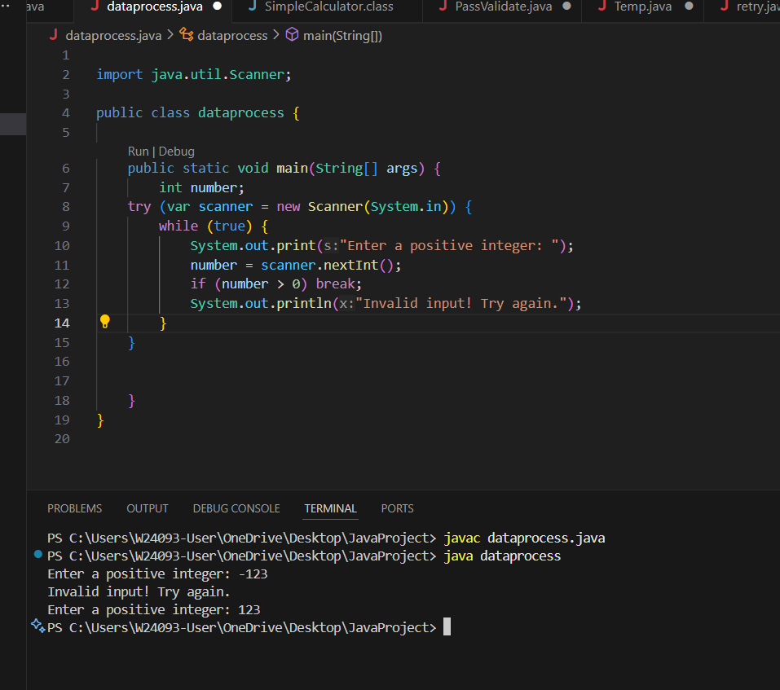

because it repeats the input check as long as the condition is false.

if statement checks only once, switch statement is for fixed cases, and for loop is for a known number of iterations, so they are not suitable here.

Q7.
B: Switch statement
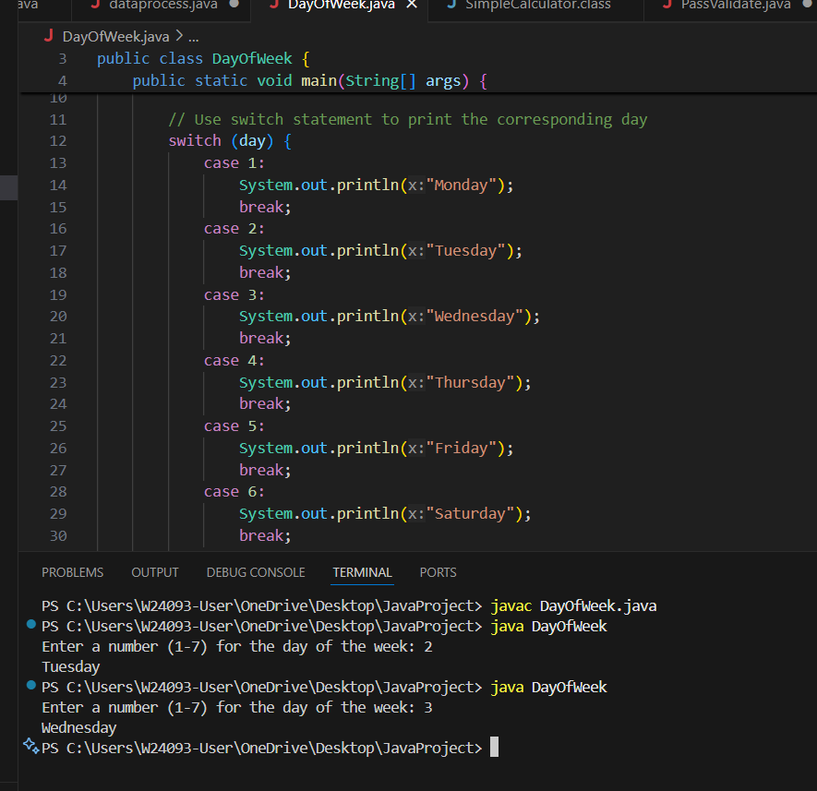

Why not others:
If-else if chain: Works, but becomes long, harder to read, and slightly less efficient.
While loop: Meant for repetition, not for choosing among fixed values.
Nested if statements: Makes the code unnecessarily complex and hard to maintain.

Q8.
C: While loop
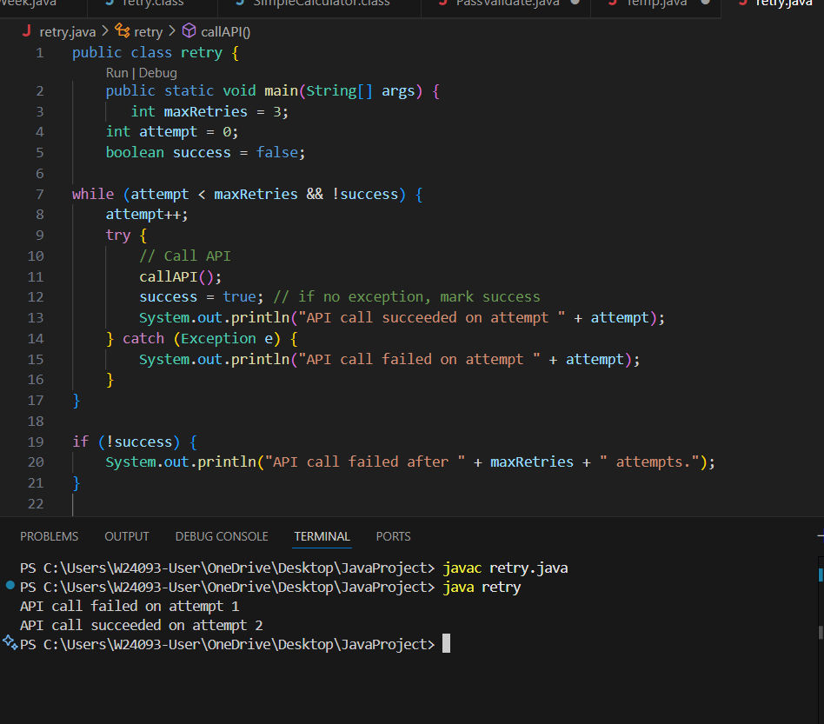

While loop is most suitable because it allows conditional repetition until success or a maximum attempt count is reached.

if cannot repeat, switch is for fixed values, and do-while is less commonly used when pre-checking a condition is needed.

